
Joseph Banks
Secondary College

Research Methods and Biological Influences
Worth 8% of the school mark
Question/Answer Booklet

PSYCHOLOGY
Unit 3
Student name : _________________________________________

Time allowed for this paper

Reading time before commencing work: thee minutes
Working time for the paper: fifty minutes

Materials required/recommended for this paper
To be provided by the supervisor:
This Question/Answer Booklet
Formulae and Data Booklet

To be provided by the candidate:
Standard items: pens (blue/black preferred), pencils (including coloured), sharpener,
correction tape/fluid, eraser, ruler, highlighters.

Special items: non-programmable calculators approved for use in the WACE examinations

Important note to candidates
No other items may be taken into the examination room. It is your responsibility to ensure that you do not have any unauthorised notes or other items of a non-personal nature in the examination room. If you have any unauthorised material with you, hand it to the supervisor before reading any further.
Structure of this paper

Section | Number of questions available | Suggested working time  (minutes) | Your Mark | Marks available | Percentage of test
Section One:  Research Methods | 2 | 20 |  | 27 | 50
Section Two:  Short Answer | 3 | 41 |  | 22 | 50
 |  | Total |  | 49 | 100

Instructions to candidates

- The rules for the conduct of Western Australian external examinations are detailed in the Year 11 Information Handbook 2016. Sitting this examination implies that you agree to abide by these rules.

- Write your answers in this Question/Answer Booklet.

- When calculating numerical answers, show your working or reasoning clearly. Your working should be in sufficient detail to allow your answers to be checked readily and for marks to be awarded for reasoning.

In calculations, give final answers to one significant figures and include appropriate units where applicable.

- You must be careful to confine your responses to the specific questions asked and to follow any instructions that are specific to a particular question.

- Supplementary pages for the use of planning/continuing your answer to a question may have been provided at the end of this Question/Answer booklet. If you use these pages to continue an answer, indicate at the original answer where the answer is continued, i.e. give the page number.

Question One (10 marks)
Read the following scenario and answer the questions that follow
Renowned Perth Psychologist, Dr Wrona, was interested in the relationship between sleep levels and an individual’s mood state. After putting an advertisement in a local newspaper, she gathered 50 volunteers (ages 18-65), who experienced the following hours of sleep per night:
1-4 OR 6-9. She then asked them a series of open-ended questions in her clinic in order to understand the nature of their respective mood states.

a) Identify the Independent Variable/s. (1 mark)

Descriptor | Marks
Amount of sleep or per night | 1

b) Identify the Dependent Variable. (1 mark)
Descriptor | Marks
Mood state | 1

c) Create an operationalised hypothesis for this research study. (4 marks)
Descriptor | Marks
Includes: operationalised IV, DV, population and comparison to control  e.g.  It is hypothesised that volunteers aged 18-65 who receive 1-4 hours of sleep will be more angry than short tempered compared to volunteers that get 6-9 hours as measured by a series of mood related open-ended questions | 0-4

d) Identify the type of data collected by the psychologist. (1 mark)
Descriptor | Marks
Subjective or qualitative | 1

e) Describe one disadvantage/limitation of using this form of data. (1 mark)
Descriptor | Marks
Subjective – more open to interpretation by the participant and the participant may lie  Qualitative – data take more time to analyse, interpret and pick out themes from  Accept any other relevant correct answer | 1

f) Describe another data collection method that Dr Wrona should use in conjunction with the data she has already collected. (2 marks)
Descriptor | Marks
Survey, observation etc  Describes the data collection method accurately  e.g. a paper or online form that participants fill out themselves asking a mix of open-ended questions, close-ended questions and likert scale questions | 1

Question Two (7 marks)
A psychologist wanted to investigate students’ attitudes towards fast food advertising on television.
- Name two qualitative methods the psychologist could use to collect data. (2 marks)
Descriptor | Marks
Interviews, surveys, observations from focus group | 0-2

- Outline one benefit of using qualitative methods for collecting research data. (1 mark)
Descriptor | Marks
Qualitative data allows the researcher to look at the meaning for human behaviour and gives a more in-depth understanding of behaviour, thought and emotion. This can help explain why certain behaviours occur. | 1

- Outline two limitations of using qualitative methods for collection research data. (2 marks)
Descriptor | Marks
Time consuming, more subjective in the analysis | 1

- Explain one way in which the role of the experimenter is different in qualitative research compared with quantitative research (1 mark)
Descriptor | Marks
The role of the researcher in qualitative researcher is more involved. They have to interpret and apply meaning to the data where as quantitative data requires no interpretation of meaning. | 1

- The psychologist designs a question that measures attitudes on a scale of 1 to 10. Identify the name of this scale. (1 mark)
Descriptor | Marks
Likert scale | 1

Question Three (10 marks)
- Define the term objective quantitative data and give two examples. (3 marks)

Descriptor | Marks
Objective data – observable measurable data or not based on perspective or point of view  Quantitative – data collected in numeric form  e.g. – heart rate, reaction time, number of yawns in an hours | 1

- Researchers were interested in the relationship between exercise and self-esteem. Data from six participants are shown in the table below.
Participant | Hours of exercise per week | Life satisfaction score
1 | 2.0 | 14
2 | 2.5 | 16
3 | 1.5 | 12
4 | 5.0 | 18
5 | 3.5 | 17
6 | 1.0 | 11

- Produce a scatter plot of the data on the grid below. (5 marks)
Descriptor | Marks
Includes both axis labels
Title includes both variables
Scaled appropriately
Line of best fit provided
Units included

- Outline what the results indicate about the association between exercise and self-esteem.
(2 marks)
Descriptor | Marks
Positive correlation  as the amount of exercise increases so does self-esteem | 1  1

Section two – Biological Influences (22 marks)
Question Four (16 marks)
- List two functions that are controlled by the
- Somatic Nervous system (2 marks)
Descriptor | Marks
Intake sensory information for processing  Output voluntary muscle movements | 1  1

- Autonomic nervous system (2 marks)
Descriptor | Marks
Controls involuntary functions of the body such as  Heart rate, pupil dilation, blood flow, breathing rate | 1

- A person is sitting inside a quiet house watching television when suddenly there is a loud noise outside.
- List three symptoms produced by the autonomic nervous system that the person might experience. (3 marks)
Descriptor | Marks
Heart rate increases, breathing rate increases, blood rushes to muscles | 1 ea

- Name the division of the autonomic nervous system that is responsible for producing these symptoms. (1 mark)
Descriptor | Marks
Sympathetic nervous system | 1

- Compare afferent and efferent neurons. (2 marks)
Similarity | Difference
Both are involved in transferring information back and forth from the CNS or brain  OR  Both can be found in the peripheral and central nervous system | Afferent is information being transmitted to the CNS / brain  Efferent is information being transmitted from the CNS / brain

- Stacey got up during the night to get a glass of water. While walking to the kitchen, she felt something brush against her leg. She did not realise that it was her cart and was so scared that she tripped and fell, hitting her head on the wall. Stacey’s mother woke up and found her daughter lying on the floor. When she asked Stacey what had happened, Stacy had trouble in hearing her and asked her mother to repeat. Stacy had problems processing what her mother was saying.
- Name the nervous system division that would have allowed Stacey used to walk to the kitchen
(1 mark)
Descriptor | Marks
Somatic nervous system | 1

- Name the lobe of Stacey’s brain that has most likely suffered trauma and explain the reason for your response, using evidence from the scenario. (3 marks)
Descriptor | Marks
Temporal lobe as this lobe is responsible for processing auditory information and she is unable to understand what her mother is saying | 1

- If Stacy woke up and was unable to process visual information, name the lobe of the brain that might have been affected. (1 mark)
Descriptor | Marks
Occipital lobe | 1

- Name the lobe of the brain responsible for processing the feeling of the cat brushing against Stacey’s leg. (1 mark)

Descriptor | Marks
Parietal lobe | 1

Question Five (6 marks)

- Name the brain lobes and describe the functions of each in the table below. (6 marks)

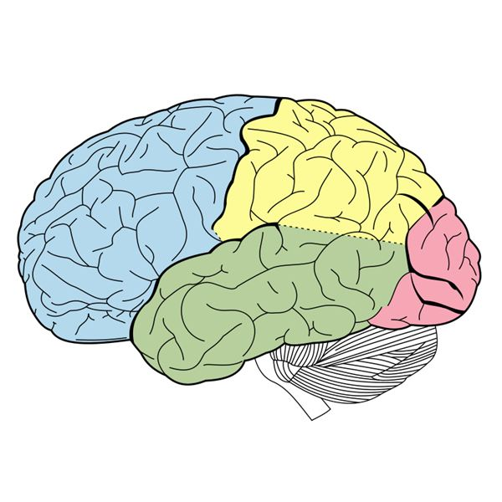
Lobe B

Lobe A

Lobe D
Lobe C

Descriptor | Marks
A: Frontal – Problem solving, critical thinking  B: Parietal – physical sensation e.g. touch  C: Occipital – processing visual information | 1

